

|  |
| --- |
| PowerShell Scripts for Crestron Control  Processors & Touch Panels  March 2021 |
| Confidential |

# Document History

|  |  |  |  |
| --- | --- | --- | --- |
| Date | Document Version | Author | Description |
| 2021-03-23 | 01.00 | Jonathan Arndt | Initial Draft |

# Contents

Document History 2

Contents 3

Synopsis 5

Purpose 5

Assumptions 5

Required Tools 5

Software Versions 6

Firmware Requirements 7

Pre-Script Execution Guide 8

Step 1) Setup an Execution Policy 8

Step 2) Import Crestron PowerShell Module (if running script attended) 8

Step 3) Create initial folder structure 8

Script Execution > Update Firmware 9

How to Connect to a Device 9

How to adjust the Ethernet settings on a Control Processor 10

How to Install PepperDash Software on a Control Processor 11

How to Install PepperDash Graphics (iPad or X-Web) on a Control Processor 12

Script Execution > Enable Authentication 14

How to Connect to a Device 14

Script Execution > Unattended 15

How to Connect to a Device 15

Notices 16

Notice of Ownership and Copyright 16

The material in which this notice appears is the property of PepperDash Technology Corporation, which claims copyright under the laws of the United States of America in the entire body of material and in all parts thereof, regardless of the use to which it is being put. Any use, in whole or in part, of this material by another party without the express written permission of PepperDash Technology Corporation is prohibited. PepperDash Technology Corporation reserves all rights under applicable laws. 16

Notice of Confidentiality 16

The material in which this notice appears is confidential to PepperDash Technology Corporation. If you have been provided a copy of this material, it is with the understanding that you will not share it with others without the express written consent of PepperDash Technology Corporation. 16

Notice of Trademark and Servicemark 16

# Synopsis

## Purpose

This documentation is written for software, developed by PepperDash, for Crestron controlled systems. The purpose of this document is to provide guidance on executing PowerShell scripts that will connect to Crestron control processors and touch panels performing automated functionality detailed in this document.

## Assumptions

It is assumed that the user of this document has the following training and/or expertise:

* Familiarity with Crestron Toolbox software
* Basic understanding of working program and folder structure on Crestron 3-Series processors and TSW touch panels
* Basic understanding of how to use and run Microsoft Windows PowerShell

## Required Tools

* Windows 7 operating system or higher
* Windows PowerShell (32 or 64 bit) or Windows Integrated Scripting Environment (ISE 32 or 64 bit), minimum Windows PowerShell version 3
* Crestron PowerShell Scripting Enterprise Development Kit (EDK)  
  <https://sdkcon78221.crestron.com/downloads/EDK/EDK_Setup_1.0.5.3.exe>
* TCP/IP network connectivity to Crestron control processor or touch panel
* Access to [PepperDash Portal](https://portal.cloud.pepperdash.com/)
* PowerShell script software package from PepperDash (obtained from [PepperDash Portal](https://portal.cloud.pepperdash.com/))

## Software Versions

|  |  |  |
| --- | --- | --- |
| Load file(s) to Crestron control Processor or Touch Panel | Release Version | Release Date |
| PDT.PowerShell.LoadScript.PS1 | v01.00 | 3/23/2021 |

|  |  |  |
| --- | --- | --- |
| Enable Authentication (from default) Script | Release Version | Release Date |
| PDT.PowerShell.Authentication.ps1 | v01.00 | 3/23/2021 |

# Firmware Requirements

The following equipment must be running the required firmware. PepperDash PowerShell scripts assume Crestron equipment is running latest provided device firmware prior to executing scripts.

|  |  |  |  |  |  |
| --- | --- | --- | --- | --- | --- |
| Manufacturer | Model | Device Type | Crestron PUF | Firmware | Release Date |
| Crestron | 3-Series | Processor | N/A | 1.7000.0021 | Jan, 2021 |
| Crestron | TSW | Touch Panel | N/A | 3.000.0014 | Oct, 2020 |

# Pre-Script Execution Guide

## General Disclaimer

All scripts written by PepperDash (and Crestron) require the PowerShell Execution Policy set to ‘remote signed’. This allows provided scripts to be ran on a local machine that were originally created on another machine. See instructions below on how to set the execution policy. Note: If you intend on utilizing PowerShell-5 ISE (Integrated Scripting Environment) for running attended scripts but later wish to utilize some other form of PowerShell command-line for unattended (example: PowerShell 7), you will need to set the execution policy to ‘remote signed’ for both PowerShell-5 and PowerShell-7.

## Step 1) Setup an Execution Policy

1. 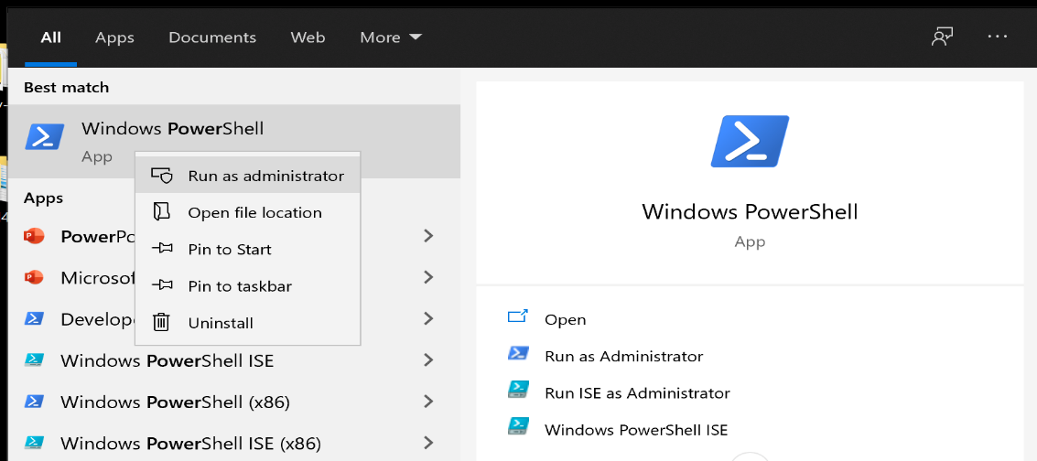Open PowerShell or PowerShell ISE **as an Administrator.**
2. 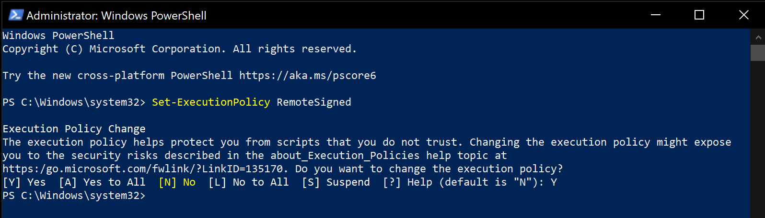Use the following command (cmdlet) to enable running remotely signed scripts (note: all PepperDash scripts utilize Crestron cmdlets which are signed): “**Set-ExecutionPolicy** RemoteSigned”
3. 3. Enter “Y” in the field to accept the execution policy

## Step 2) Create initial folder structure

1. Create a new folder on your desktop for running PepperDash scripts. Call this new folder something easily referenced (typically this folder is called, ‘PepperDash-Scripts’.)
2. Within the ‘PepperDash-Scripts’ folder there should be sub-folder called, ‘Scripts’ where the actual PowerShell scripts reside.
3. If you desire to run a PepperDash script unattended or desire to load files to a Crestron controller, then create another folder within the ‘PepperDash Scripts’ root folder called, ‘Packages’. Running PepperDash scripts unattended requires the use of a JSON formatted address book file with the file extension of *.pda (example: addressBook.pda). The address book file must be Java-Script-Object-Notation formatted or JSON. Example address books will be provided.
4. No need to create the ‘Logs’ folder as this folder and any associated logs will be generated automatically.

## 

# Script Execution > Update Firmware (Attended)

## Update Crestron Control Processor or Touch Panel Firmware (attended)

1. 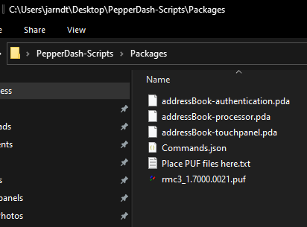Place firmware PUF file in the ‘Packages’ folder.
2. Navigate to provided PowerShell script titled, **‘PDT.PowerShell.LoadScript.PS1**’ (Note: This file should be located in the ‘Scripts’ folder).
3. If you are running the scripts attended. Hold Shift and Right click in the File window that contains the name of the PowerShell command you want to run. Select “Open Powershell window here”

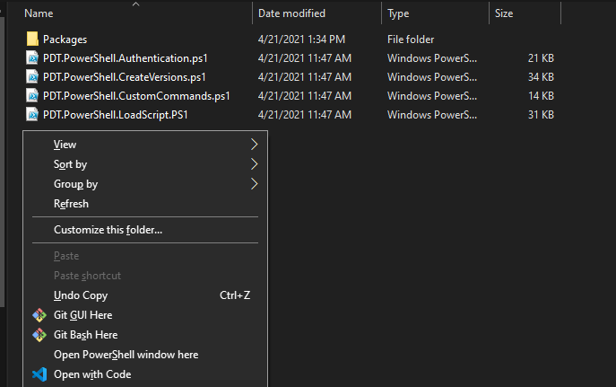

1. To run the script, enter “.\”*name of the desired powershell script”* and Enter.

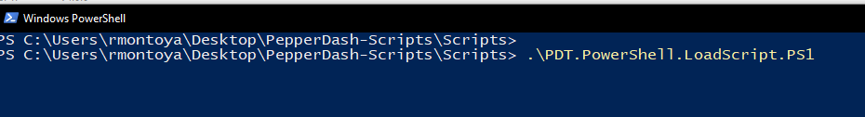

1. 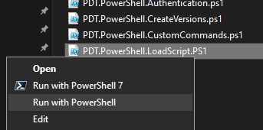If you are running the scripts unattended, Right-click file and select option to ‘Run with PowerShell’. PepperDash recommends running scripts in a PowerShell command console.
2. If script discovers multiple files possible to load to the processor or touch panel the script will query for a choice of files to load.

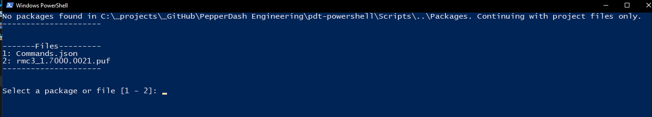

1. Enter a value for the desired file selection. The example above allows for a value of either ‘1’ or ‘2’. *Note: At this prompt you are not able to load multiple files to a Processor or Touch Panel. Should you desire to load multiple files please utilize the separate PowerShell script titled, ‘LoadScipt’ for this purpose.*
2. If prompted with “Is this for a Touchpanel or Processor, Enter the device **Exactly** as it is shown in the Powershell. Continue with this for all following questions.

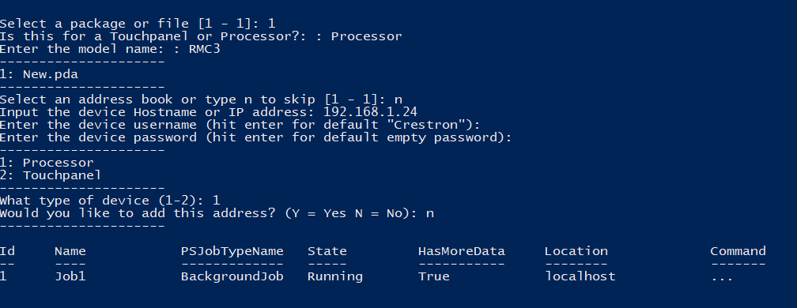

1. Provide the ‘device username’ of the processor or touch panel required to connect via SSH. If the device credentials or authentication have not been setup the option to choose the default value of ‘Crestron’ is allowed by hitting enter when prompted.
2. Provide the ‘device password’ of the Processor or touch panel required to connect via SSH. If the device credentials or authentication have not been setup the option to choose the default empty value is allowed by hitting enter when prompted.
3. Provide the device type that files will be loaded to. A value of ‘1’ for Processor or ‘2’ for Touchpanel are the only allowed values.

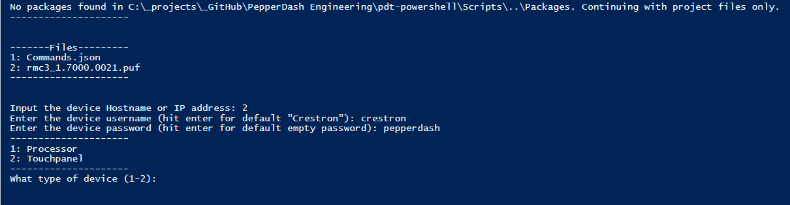

1. The script will prompt asking if the address provided should be added to an existing address book. By default, this value should be ‘N’ for no.
2. Wait for confirmation of successful completion.



# Script Execution > Enable Authentication

## Execute ‘Authentication’ Script (attended execution)

1. Start Windows PowerShell or hold shift and Right click in the window where the Powershell command exists and “Open Powershell window here”



1. While running Powershell from a command line, type in the full path to the authentication script with the prefix: powershell.exe -Command “&. The path must be in single quotes and the end of the command must end with double quotes. Example below:
   1. While running Powershell from f holding shift and Right Clicking in the window that contains your Powershell command, paste the “.*name of the desired powershell script”*



1. Enter the new username desired for the device after the prompt, “NewUsername”.
2. Enter the new password desired for the device after the prompt, ‘NewPassword”.
3. If using an address book enter the desired address book from the list or type ‘n’ to skip this selection.
4. If using an address book enter the desired address or ‘a’ for all or ‘n’ to skip.
5. If no address book file (*.pda) is discovered by the script (located in the Packages folder) enter the device hostname or IP address.
6. Enter the devices’ current username (note: if authentication has not yet been setup the username is ‘crestron’). Hit enter for default ‘crestron’.
7. Enter the devices’ current password (note: if authentication has not yet been setup the password is blank or empty). Hit enter for default empty password.

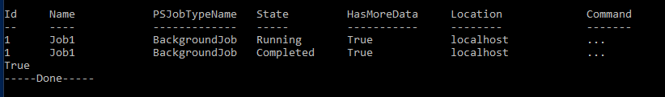Script will provide visual indication of ongoing job running in the background, indication of when the job has completed, and will automatically generate logs showing status of authentication script for each device connected to.

1. Wait for confirmation of successful completion.

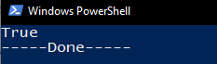

## Execute ‘Authentication’ Script (Unattended execution)

1. Navigate to the _AuthenticationScript.bat file, it is recommended by Pepperdash that you only edit these files in the .json format (Using tools such as Visual Studio Code, opposed to Notepad or Notepad++)
2. Right click the file and select “Open with Code” or any JSON editor you use.

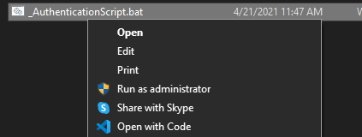

1. While inside the editor, input all information within the “ “ that pertains to the devices you will be working with. **Note** It is recommended that you only have 1 address book in the “Packages” folder to be leep the “SelectAddrBook” and “SelectAddress” fields the same across the devices

 

1. After editing the fields .bat file. Return to the folder where the file exists, and double click the _AuthenticationScript.bat file.
2. A command window will prompt an address book, select 1,2, or a for all
3. After entering you will see the script in progress, then a completed “---Done---” Message

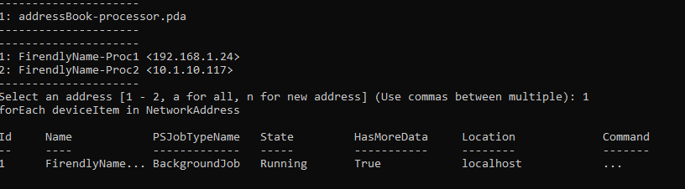

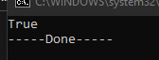

## Execute ‘Custom Commands” Script (attended execution)

1. Start Windows PowerShell or hold shift and Right click in the window where the Powershell command exists and “Open Powershell window here”



1. If running PowerShell from a command line, type in the full path to the authentication script with the prefix: powershell.exe -Command “&. The path must be in single quotes and the end of the command must end with double quotes. Example below:
2. If running PowerShell from shift and Right Clicking in the window that contains your Powershell command, paste the “.*name of the desired powershell script”*

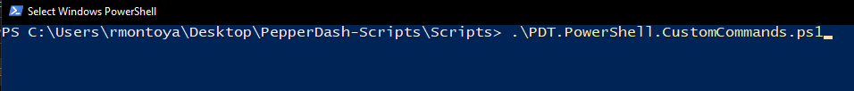

1. The script will be looking for the Command file. Enter the file location of the Custom Command .json file.
2. Select an address book to pull the IP Address from [1 – 4] or “n” to skip
3. If skipped, Enter the IP Address of the processor you want to run the commands on
4. Enter the Device Username (Or hit enter if the default username is “crestron”
5. Enter the Device password (Or hit enter if the default username is empty “”
6. Select Enter and wait for a successful completion message.

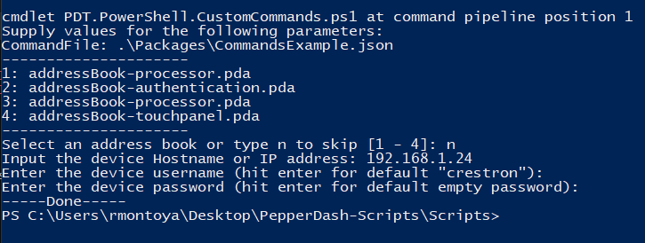

## Execute ‘Custom Commands” Script (unattended execution)

Navigate to the _LoadScriptt.bat file, it is recommended by Pepperdash that you only edit these files in the .json format (Using tools such as Visual Studio Code, opposed to Notepad or Notepad++)

1. Right click the file and select “Open with Code” or any JSON editor you use.



1. While inside the editor, input the file path where the Customs Scripts “PDT.PowerShell.LoadScript.PS1” exists



1. After editing the fields .bat file. Return to the folder where the .Bat file exists, and double click the _LoadScript.bat file.
2. A command window will prompt a package to select based on how many files exist in the Packages folder
3. Select an address book or n to skip
4. Select the processor you are working with
5. After entering you will see the script in progress, then a completed “---Done---” Message

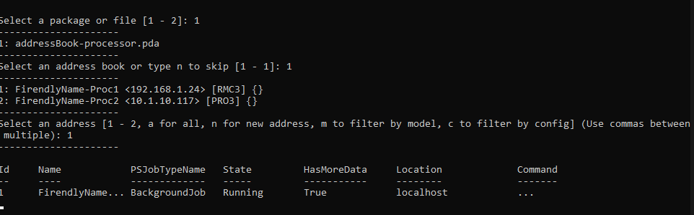



# Script Execution > Unattended

## How to Connect to a Device

1. Connect to the device using Crestron Tool Box > System Info
2. Press the [Pencil] button  in the bottom of the System Info window
3. Select the [TCP] radio button
4. Enter the IP address or hostname (see IP addresses above) into the [IP Address/Hostname] field
5. Press [OK]

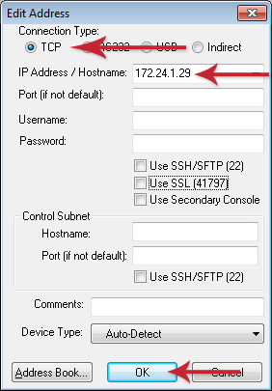

# Notices

## Notice of Ownership and Copyright

## The material in which this notice appears is the property of PepperDash Technology Corporation, which claims copyright under the laws of the United States of America in the entire body of material and in all parts thereof, regardless of the use to which it is being put. Any use, in whole or in part, of this material by another party without the express written permission of PepperDash Technology Corporation is prohibited. PepperDash Technology Corporation reserves all rights under applicable laws.

## Notice of Confidentiality

## The material in which this notice appears is confidential to PepperDash Technology Corporation. If you have been provided a copy of this material, it is with the understanding that you will not share it with others without the express written consent of PepperDash Technology Corporation.

## Notice of Trademark and Servicemark

PepperDash®, Sentegy®, AVUX® and AV360® are the marks of PepperDash Technology Corporation, registered with the U.S. Patent and Trademark Office. PepperDash Portal™, PepperDash Essentials™, and PepperDash Connect™ are the unregistered marks of PepperDash Technology Corporation. Any use, in whole or in part, of these marks by another party without the express written permission of PepperDash Technology Corporation is prohibited.



PepperDash | 800.377.9112 | www.pepperdash.com